Revised Research Brief
Vehicle-Aware Dynamic Alternative Path Planning for Dhaka
Supervisor-directed update to the current ACO-based thesis framework
Prepared by | Sourav Debnath (Roll 2007109)
Purpose | Briefing document for supervisor review before coding and experiments
Date | 2026-03-24

Executive summary. This revised brief reframes the existing dynamic ACO work into a vehicle-aware and disruption-aware path planning framework for Dhaka. The key supervisor-directed additions are: route hierarchy, category-wise road feasibility, three blockage-response cases, and a pool-based alternative path mechanism that is expected to reduce online reroute iterations, computation time, and computational power. Case 3 is the proposed method, but it remains a research hypothesis until validated experimentally.

1. Starting point and revised research focus
The current weekly work started from improved ACO-based path planning with combined route optimization. The revised focus is narrower and more practical: when a route is suddenly blocked, how quickly can each vehicle category be diverted through feasible alternative paths in Dhaka? The framework must therefore move beyond a single best route under normal traffic and explicitly model route hierarchy, vehicle restrictions, disruption handling, and network-wide reroute effects.
The new design must operate at two levels simultaneously: (i) individual source-destination planning and (ii) combined network planning where multiple pairs may share roads. This matters because a sudden blockage does not affect only one traveler; it affects every pair that currently depends on the blocked link.
2. Route hierarchy and vehicle categories
The path planner should assign each edge to a route hierarchy such as main route, link route, subroute, or mini route. Each route must also store width and road-condition information so that feasibility is checked before path selection, not after.
Vehicle category | Main | Link | Sub | Mini
Cat-1: Truck | Yes | Conditional | No | No
Cat-2: Bus | Predefined | Predefined / Conditional | No | No
Cat-3: Private car, Microbus | Yes | Yes | Conditional | Conditional
Cat-4: Rickshaw, Van, Bike | Yes | Yes | Yes | Yes
The table above is a conceptual rule set for implementation. In the actual code, the exact thresholds should be configurable. For example, a private car or microbus may enter more route classes than a truck or bus, but still should not be allowed on every mini route unless width and local condition permit it. Bus movement must remain tied to predefined corridors.
3. Stable-state planning before any disruption
Before any sudden block is applied, the system should compute a stable network state. This stable-state stage is where the proposed method gains its future speed advantage. For each source-destination pair and vehicle category, the system first builds a feasible subgraph according to route width, road condition, and vehicle access constraints. It then computes the stable best route under the combined network setting and stores the result.
The new contribution is the pool. A pool is a set of five alternative feasible paths for the same source-destination pair and vehicle category. The pool must be sorted from best to worst. In addition to pair-level pools, the framework should also preserve a network-level view so that shared-edge dependence and reroute conflicts can be analyzed across the whole network.
During steady-state pool construction, links with higher prior disruption risk can be penalized so that the pool becomes more resilient. The examples of Shahbagh and Science Lab are illustrative high-risk links only; the final implementation should treat such fragility as configurable prior information, not as a fixed hard-coded claim.
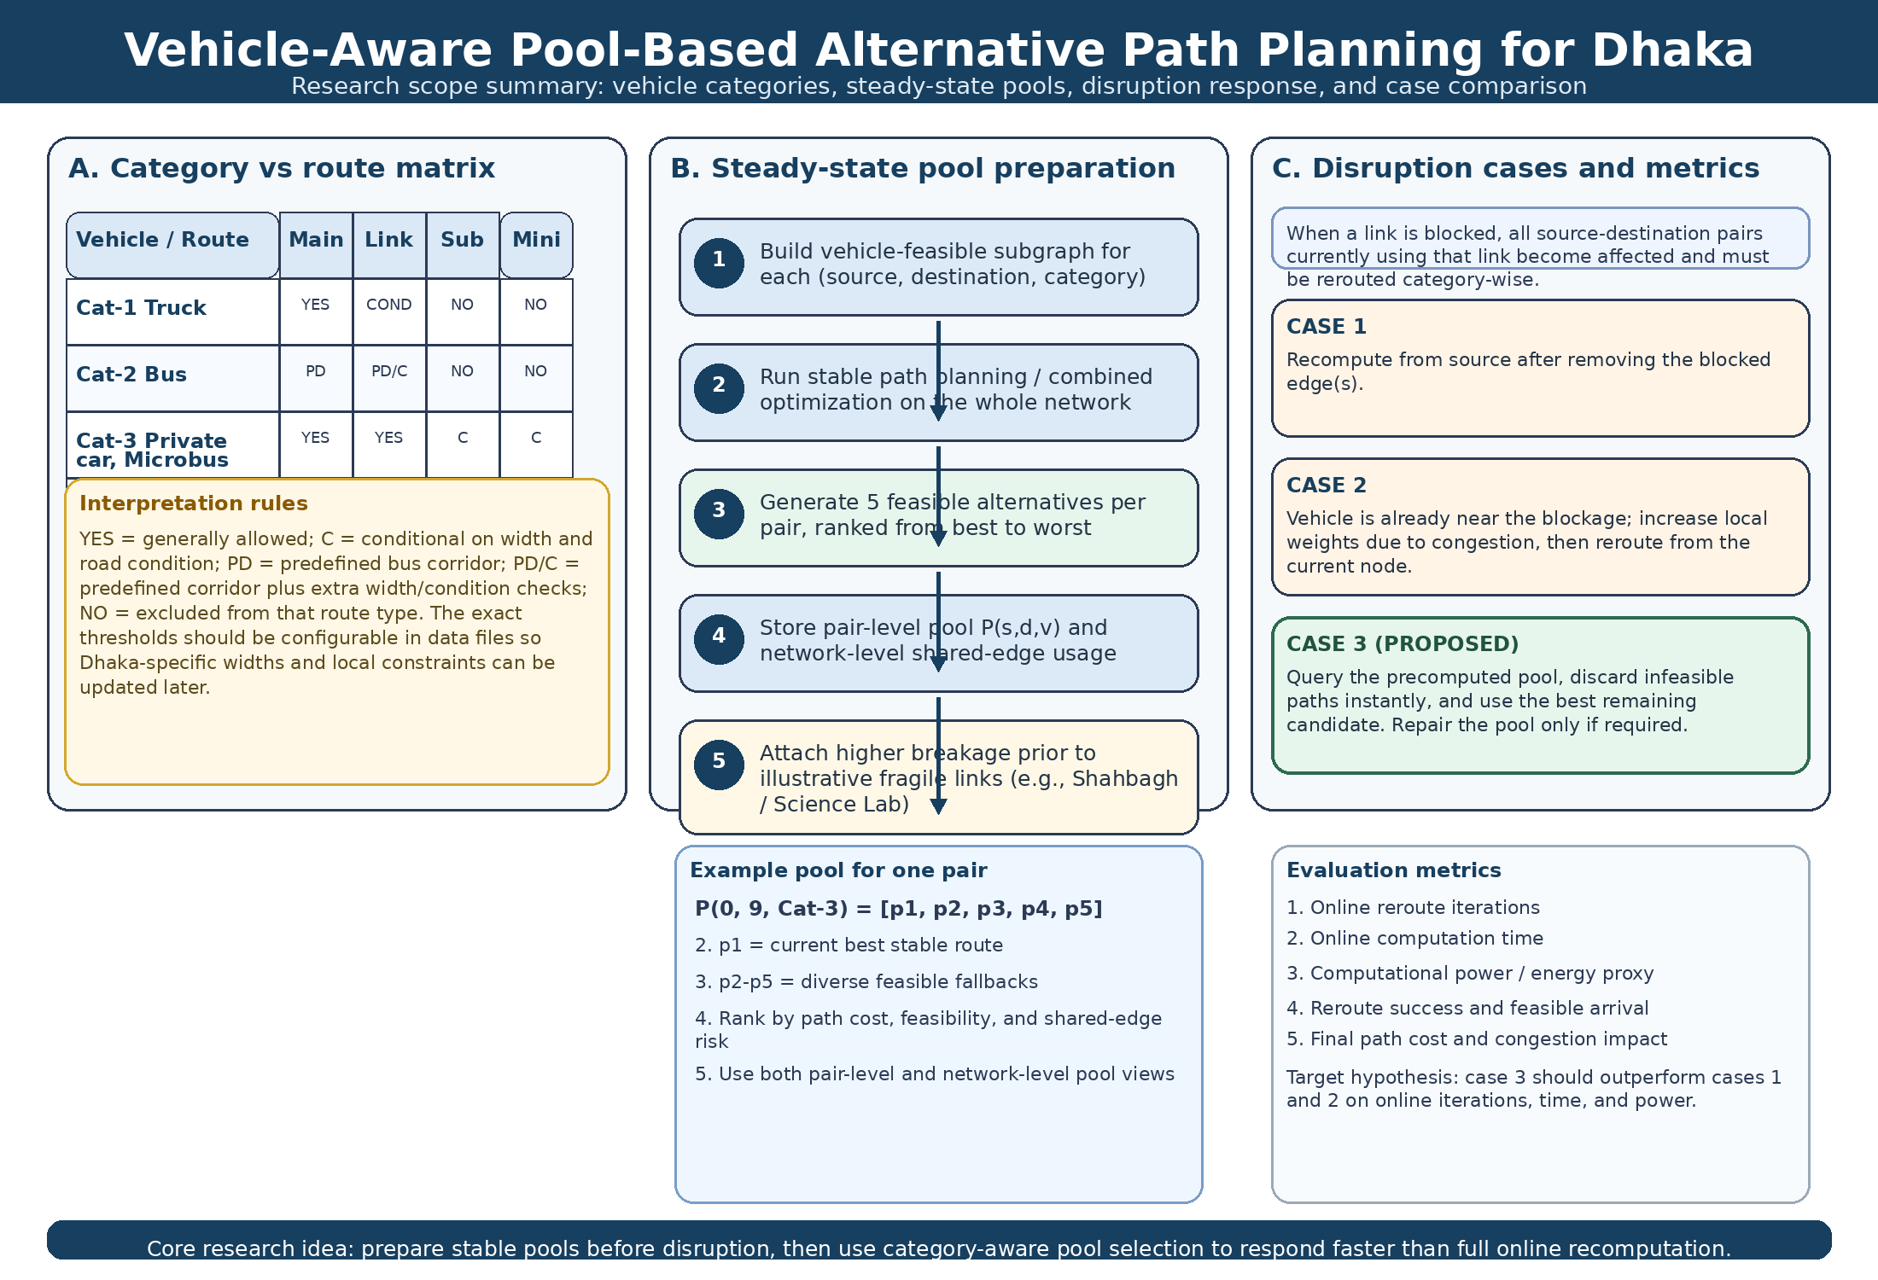
Figure 1. Research scope summary showing vehicle-route compatibility, steady-state pool generation, and the three online rerouting cases.
4. Three blockage-response cases to be compared
The revised framework must compare three cases after a sudden blockage, broken link, or protest-based closure. The comparison must be performed for all source-destination pairs and all relevant vehicle categories, not only for one illustrative example.
Case | Starting point | Online action | Expected online cost
1 | Source node | Remove the blocked edge(s) and recompute from source on the feasible graph. | Highest
2 | Current node / local position | Increase weights around the blocked area because vehicles are already congested there, then reroute from the current node. | High
3 | Precomputed pool (proposed) | Query the five pooled paths, discard infeasible ones, select the best remaining candidate, and refresh the pool only if needed. | Lowest (target hypothesis)
Illustrative example only: source 0 to destination 9 with blocked edge 5-9
Case 1 recomputes an alternative route from source 0 to destination 9 after removing edge 5-9 from the feasible graph. Case 2 assumes the vehicle has already progressed to the blocked area; therefore the rerouting starts from the current node near edge 5-9 and increases local weights to reflect congestion buildup. Case 3 looks up the precomputed pool for the same pair and vehicle category, removes any candidate path that contains the blocked edge, and immediately selects the best remaining feasible path. The example is only explanatory; the real system must generalize this logic to all pairs.
5. What must be measured experimentally
The supervisor-directed comparison is not only about final route cost. It is about online rerouting efficiency under sudden disruption. Therefore each case must be evaluated using the same disruption events and the same source-destination coverage.
Metric | Why it matters
Online reroute iterations | Shows how much search is still needed after the block appears.
Online computation time | Direct measure of how quickly an affected vehicle can receive an alternative path.
Computational power / energy proxy | Captures the efficiency cost of online rerouting; if true power is unavailable, use a clearly labeled proxy.
Reroute success and feasible arrival | Confirms that the alternative path is category-wise valid and actually reaches the destination.
Final path cost and congestion impact | Ensures faster rerouting does not produce unusable or excessively costly paths.
For power measurement, the framework should not invent hardware values. If direct power tracing is unavailable, a fixed-platform proxy such as CPU process time, or a derived energy proxy under controlled hardware conditions, should be used and explicitly labeled as a proxy.
6. Why case 3 is the proposed contribution
Case 3 is designed to shift a portion of the computational burden from online rerouting to offline stable-state preparation. Instead of solving the entire reroute problem from scratch after every sudden block, it first prepares pools in advance. When the disruption occurs, the online step becomes a fast feasibility filter and ranked selection problem. This design is expected to reduce online iterations and reroute time relative to cases 1 and 2, especially when many pairs are simultaneously affected by the same blocked edge.
However, this advantage must be presented as a hypothesis, not as a completed result. The contribution of the present stage is the framework design, the implementation plan, and the definition of measurable experiments that can prove or disprove the expected advantage.
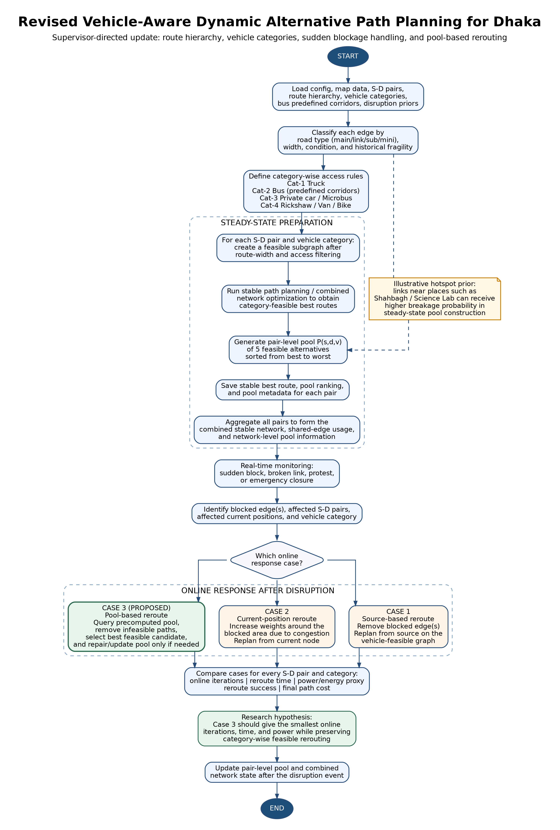
Figure 2. Modified flowchart of the revised vehicle-aware, pool-based dynamic rerouting framework.
7. Immediate implementation tasks in the current codebase
The weekly_update_10 repository should be extended rather than discarded. The main implementation tasks are: enrich the edge schema with road hierarchy, width, and vehicle-access fields; encode predefined bus corridors; add disruption-prior fields for pool construction; generate pair-level pools and network-level pool statistics; simulate sudden block events; identify all affected source-destination pairs after a closure; and save case-wise result files that enable direct comparison.
The current codebase already contains the main planning files, dataset generation, configuration, and prior reports. Therefore the short-term goal is to build a vehicle-aware experimental extension on top of that structure rather than to start a new standalone project.
8. Proposed hypotheses for supervisor approval
H1. Category-wise access control will prevent infeasible reroutes and make the Dhaka model more realistic.
H2. Pair-level and network-level pools will improve resilience because multiple affected source-destination pairs can be redirected without solving the full optimization problem from scratch each time.
H3. Case 3 is expected to achieve lower online iterations, lower reroute time, and lower computational power than case 1 and case 2, while maintaining destination reachability.
H4. Including prior disruption risk during steady-state pool construction can reduce dependence on fragile links and improve post-blockage recovery quality.
9. Closing note
This revised brief translates the supervisor’s verbal directions into a structured research design. The next step is to implement the vehicle-aware data model, generate pools, simulate disruption events, and run the three-case comparison over all source-destination pairs and relevant vehicle categories.
10. Background basis used for this revision
The revised framing keeps the existing weekly dynamic-routing work as the starting point and draws on two useful ideas from the reference material: (i) route hierarchy and alternative connectivity as a resilience principle in Dhaka-like networks, and (ii) the value of partial / reduced online update logic for lowering computational effort in ACO-style optimization. These ideas support the motivation for a vehicle-aware pool-based case 3.

